Installing nmstate operator for configuring external connectivity to vm
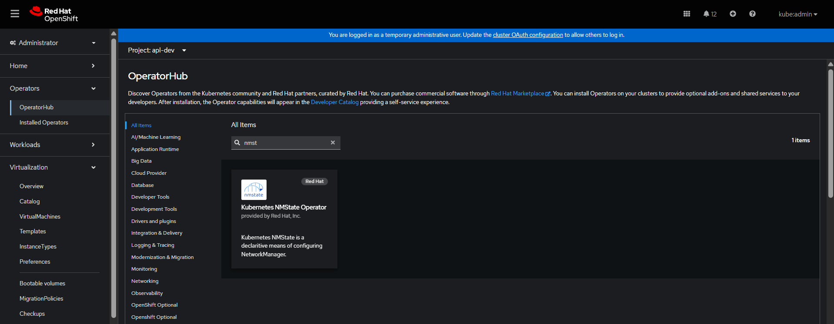
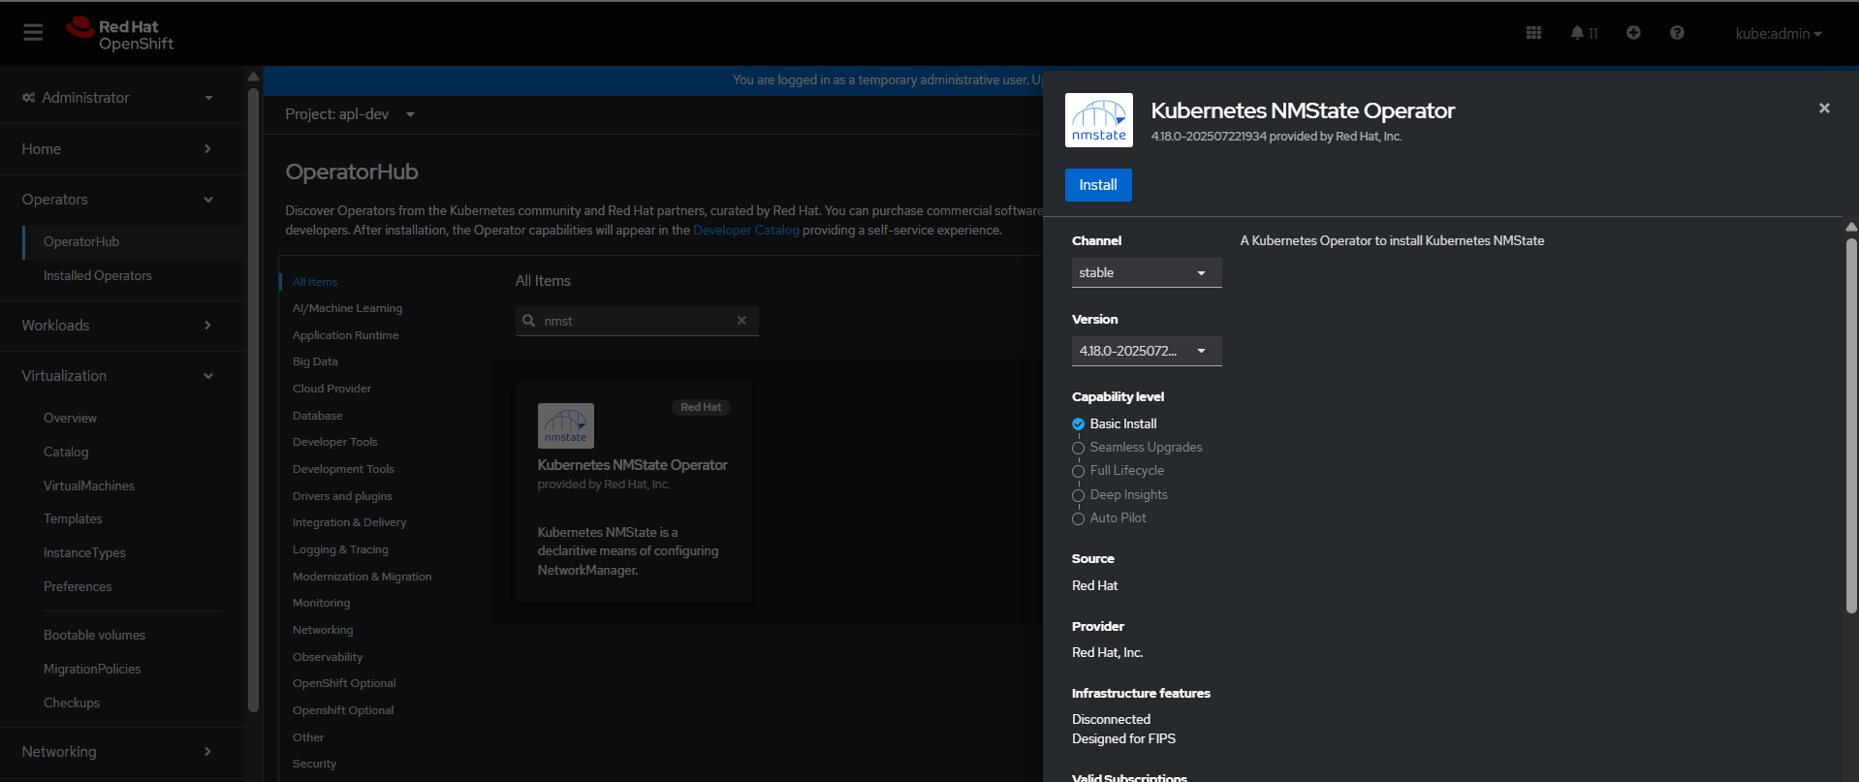

Click on install and it will install the operator.
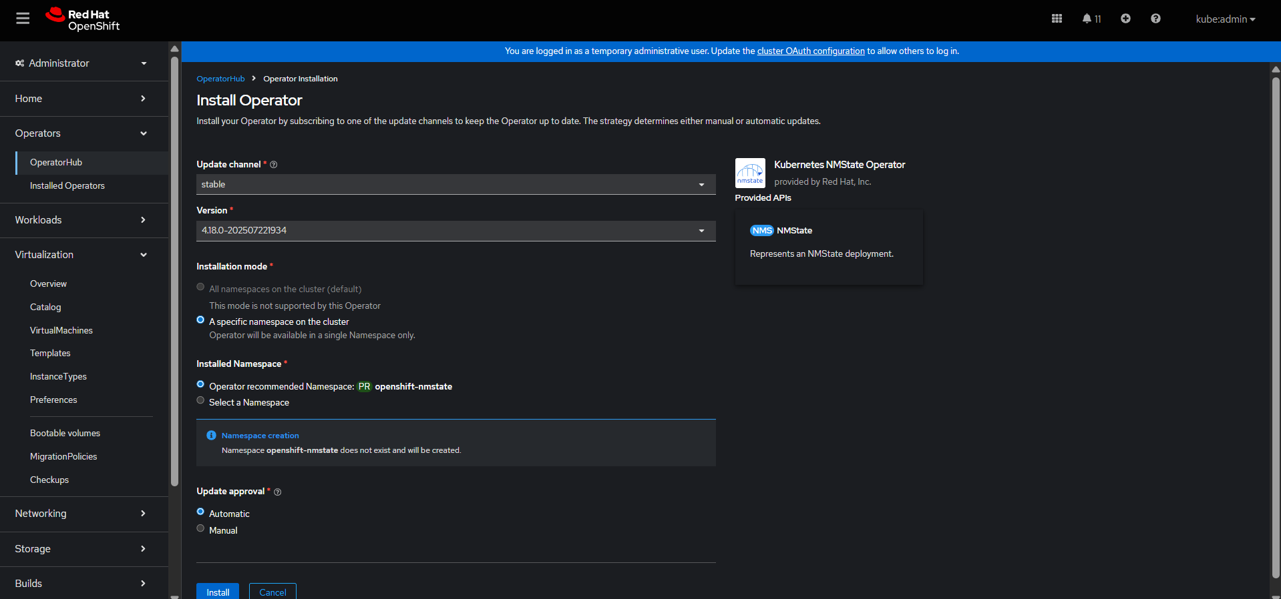
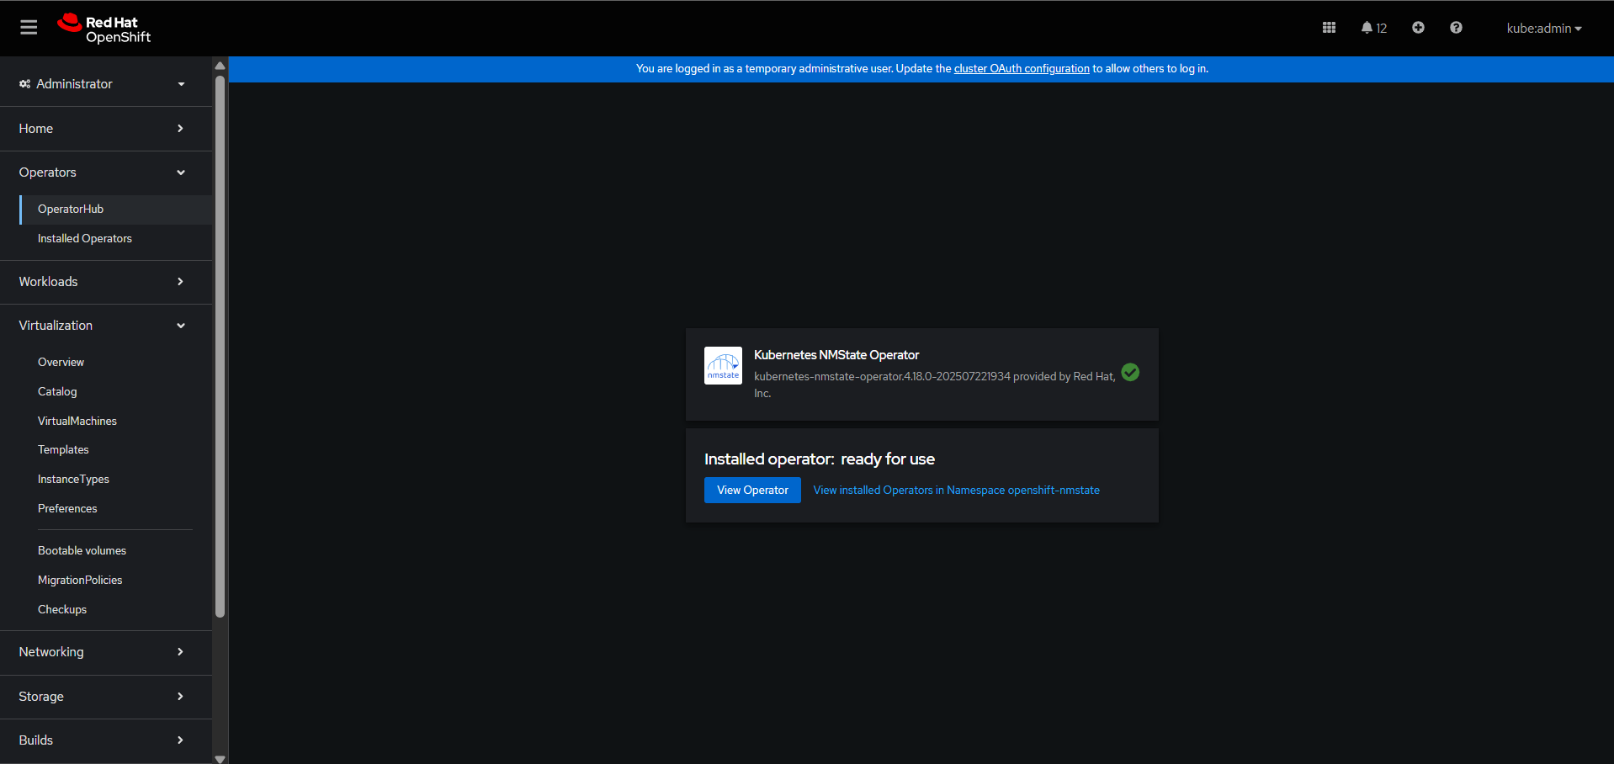

Click on nmstate create instance.
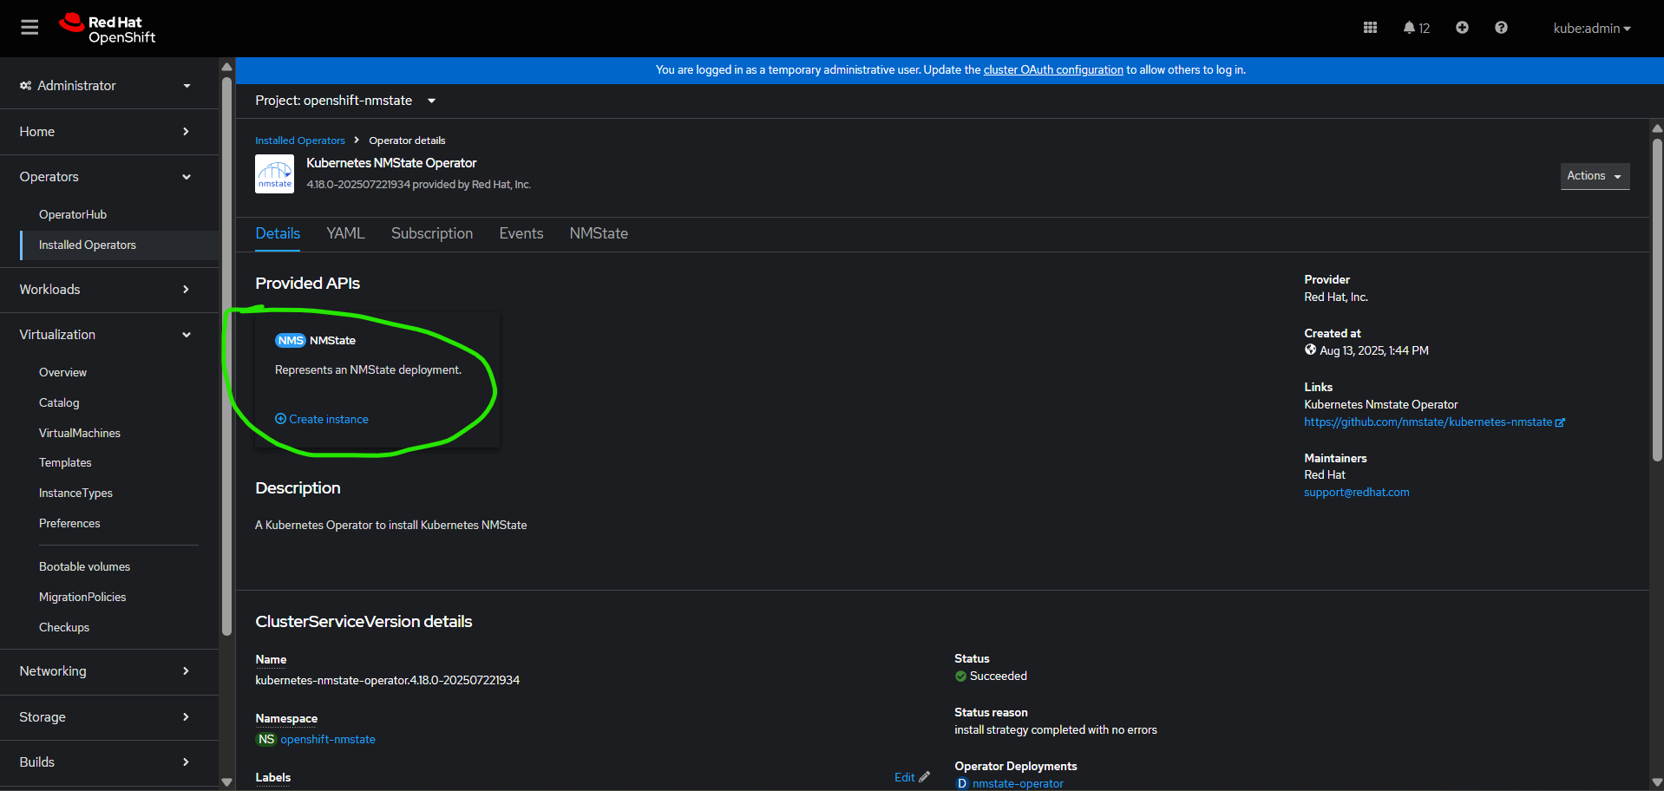
Select the form view and click create.
Verify by terminal whether new pods are creating or not.
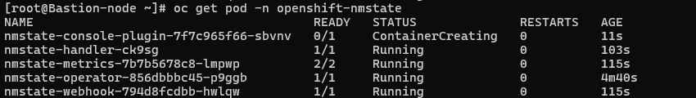
Take ssh of node and find the network port of the node.
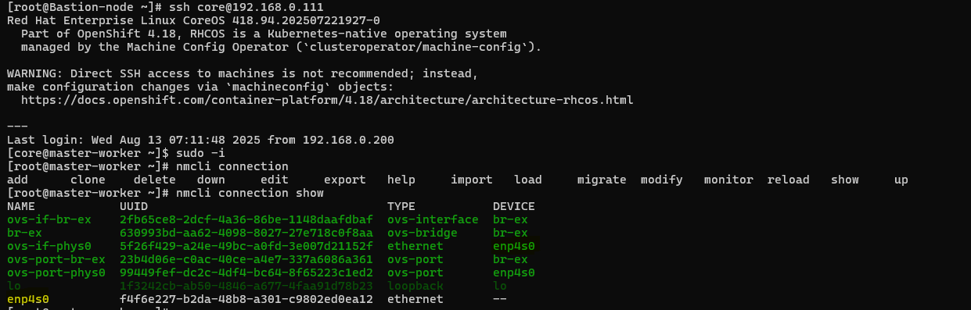

Come back to bastion node and create a folder like below:
mkdir –p /root/external-connectivity
touch 1-bridge-external.yaml
touch 2-br-ex-nad-apl-dev.yaml
touch 3-br-ex-nad-apl-prod.yaml
vim 1-bridge-external.yaml
apiVersion: nmstate.io/v1
kind: NodeNetworkConfigurationPolicy
metadata:
name: bridge-external
spec:
nodeSelector:
kubernetes.io/hostname: master-worker
desiredState:
interfaces:
- name: br-ex
type: linux-bridge
state: up
bridge:
options:
stp:
enabled: false
port:
- name: enp4s0
- name: enp4s0
type: ethernet
state: up
vim 2-br-ex-nad-apl-dev.yaml
apiVersion: k8s.cni.cncf.io/v1
kind: NetworkAttachmentDefinition
metadata:
name: br-ex-nad
namespace: apl-dev
spec:
config: |
{
"cniVersion": "0.3.1",
"type": "bridge",
"bridge": "br-ex",
"ipam": {
"type": "static",
"addresses": []
}
}

Vim 3-br-ex-nad-apl-prod.yaml
apiVersion: k8s.cni.cncf.io/v1
kind: NetworkAttachmentDefinition
metadata:
name: br-ex-nad
namespace: apl-prod
spec:
config: |
{
"cniVersion": "0.3.1",
"type": "bridge",
"bridge": "br-ex",
"ipam": {
"type": "static",
"addresses": []
}
}

